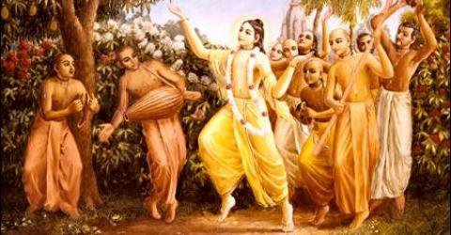

January 2011 Edition
www.soldiersofgodhead.yolasite.com
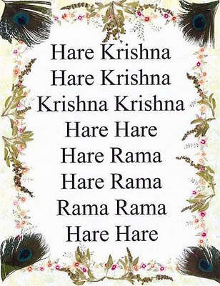

Contents
Sr.no Topic Page no.
- The bodily conception of life. 5

- Victims of sense gratification. 9

- Transcendental Pleasure. 13

- The original home. 19

- Simple living and high thinking. 27

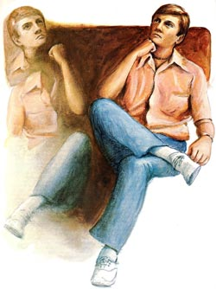
Are we bodies or souls?

- The bodily conception of life.

“I am this body.” “The purpose of my existence is to satisfy my senses.” “My duty is to satisfy the senses of my bodily relations i.e family and relatives and to increase my bodily possessions for leading a comfortable life.” “I the body is born in India therefore I am an Indian and this is my motherland.” “He is born in America therefore he is an American.” These are some of the notions that most of us possess. When we identify ourselves with our body in this manner, it is known as the bodily conception of life. This bodily conception of life is the root cause of our sufferings and miserable condition in this material world. Identifying ourselves with our body, we tend to think that it is only by sense gratification that we can remain happy and satisfied in this world. Our duty is to assist our family, relations and friends in their sense gratification and increase our bodily possessions for leading a luxurious and happy life. And in order to fulfill this so called purpose of existence we spend our entire life time in struggling to accumulate wealth which is key to obtaining objects of sense gratification which we think will make us truly happy and satisfied. Identifying himself with his body, one goes on struggling to accumulate more and more wealth with the expectation of a “better tomorrow”. But this “better tomorrow” never comes in his life and in spite of having accumulated a large amount of wealth and objects of sense gratification one dies unsatisfied (since desires are never ending) only to be born again in this material world to begin the struggle once again with the same result at end! In this way the conditioned soul who identifies himself with the body is going on struggling life after life.
So what is our true identity and how can we transcend the cycle of birth and death? Aham Brahmasmi “I am spirit soul.” This is the true identity of the conditioned soul. When he finally arrives at this conclusion after millions and millions of births of suffering in this material world, he begins to inquire in the right direction. This inquiry is called Athato Brahma Jigyasa. “Now I have the body of a human being owing to past good deeds.” “Now I must know what the purpose of my existence is and must work towards fulfilling that purpose thereby making my life successful.” When the conditioned soul makes such an inquiry, he has already started walking on the path to liberation from the material pangs and towards endless transcendental pleasure. The conditioned soul must make such an inquiry from a pure devotee of the supreme lord who alone can direct him in the right direction. When one makes such inquiry to an impious soul or to himself or to a person who is devoid of transcendental knowledge then he is bewildered and misdirected. Hence, it is of utmost importance to approach a bonafied spiritual master or a pure devotee of Lord Krishna to obtain proper instruction and directions. When one receives knowledge of the self (soul) and of the Supreme Personality of Godhead, Lord Sri Krishna, one transcends the bodily conception of life and in spite of living in this material world, becomes a liberated soul. Understanding one’s true identity, one must free himself of all bodily designations. “I am this body.” “I am an Indian.” “I am a doctor.” “I am a teacher.” These bodily designations must be given up. It is mentioned in the Narada Pancharatra: Sarvopadhir vinirmuktam tat paratvena nirmalam. Hrishikena Hrishikesa sevanam bhaktir ucyate. Giving up all bodily designations one must engage in the service of the supreme lord Sri Krishna. By the grace of Lord Krishna and His representative the bonafied spiritual master, one realizes his true identity that he is not this body but spirit soul an infinitesimal part and parcel of Lord Krishna and realizes the true purpose of his existence that is to serve the lotus feet of the Supreme Lord Sri Krishna. By realizing and fulfilling the purpose of one’s existence, one becomes a fit candidate to go back home, back to Godhead.

Hare Krishna!

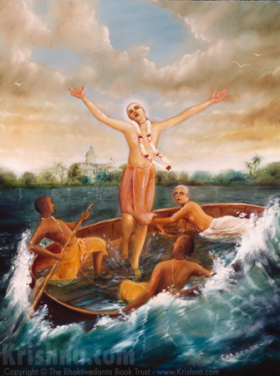
Only by surrendering at the lotus feet of the Supreme Personality of Godhead Lord Sri Krishna, can one cross over the ocean of material nessence.

- Victims of Sense Gratification.
Every living entity in this material world be it an ant, an elephant or a human being, thinks that “by gratification of my senses, I shall remain happy and satisfied.” But this kind of thinking is the result of our bodily conception of life. Owing to such mentality people strive hard day in and day out to gather objects of sense gratification. There is no end to desire for sense gratification. Therefore the conditioned soul in order to remain “happy and satisfied” in this material world is struggling all the time. As long as one does not let go of all desires of sense gratification and engages his senses in the service of Lord Sri Krishna, there can be no true and eternal happiness and satisfaction in the life of any living entity. As parts and parcels of Lord Krishna, it is our nature and duty to serve Him. But because of our forgetfulness of our relationship with Krishna we are serving the material energy in this material world and suffering without even realizing that we are actually suffering! This is illusion or maya. When one accepts his suffering as enjoyment then he is illusioned. There is no need to struggle hard for gathering objects of sense gratification. But because the conditioned soul has wrongly concluded that only sense gratification can make him happy, he is struggling. This is how one suffers in this material world. When one gives up desires for sense gratification and lives by humble means only to fulfill the needs of himself and his family and directs his energy, time and efforts in the service of the Supreme Lord Sri Krishna by discharging devotional service then the living entity although living in this material world experiences transcendental pleasure and freedom from strees, depression, anxiety and other problems which are common in ordinary conditioned souls.
When a conditioned soul thinks that it is only sense gratification that can solve his problems, make him happy and satisfied and considers sense gratification as the purpose of his existance then he is victimised by his senses. Such a person is called a Godasa (Go-senses, dasa- servant) or the one who is a servant of his senses. Since most of the people in this material world are Godasas and engaged in sinful activities of sense gratification, this world is also called Maithunyagarbha or the place where sense gratification and sex life is more prominent than devotional service. But when one gains control of his senses by engaging them in the service of Krishna one becomes a Goswami (Go-senses, Swami-master) or the one who is the master of his senses. At the end of the third chapter of the Bhagavad Gita, Lord Krishna tells Arjun that it is not impossible to gain control over the senses, because the mind is subtle than the senses, intelligence in more subtle than the mind and the soul (the living entity himself) is above intelligence. Therefore the living entity is stronger than the senses. When one receives transcendental knowledge, one gains intelligence by which he is able to control the mind. When the mind is controlled and engaged in the service of Krishna, then the senses are also engaged in serving the lotus feet of Krishna. In this manner one gains control over his senses and engages in the service of Lord Sri Krishna thereby purifying his existence and becoming a fit candidate to go back home, back to Godhead.

Hare Krishna!

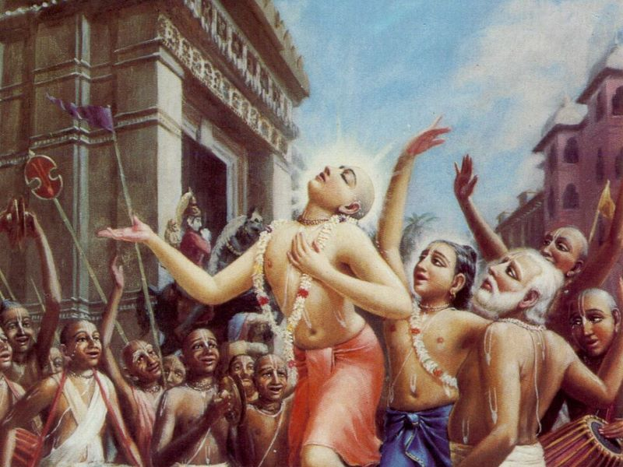
Lord Chaitanya Mahaprabhu in transcendental ecstasy
- Transcendental Pleasure.
In this material world, whatever form of sense gratification one “enjoys” such enjoyments are temporary and sinful in nature. Whether it is listening to your favorite music, watching your favorite movies, eating your favorite food stuffs, or smelling your favorite flowers or sex pleasure, all these forms of sense enjoyments give you a sense of pleasure but this so called pleasure is false since it is temporary. Since ‘pleasure’ is the most sought after thing in the material world, owing to its temporary nature it does not last forever. This is the reason why a conditioned soul has to keep struggling in this material world to be able to gather and enjoy the objects of sense gratification. In this struggle he forgets his constitutional position and relation with Lord Krishna and this forgetfulness is the cause of all misery and suffering in the material world. When one revives this forgotten relationship, he at once becomes free from the material pangs of misery and suffering and begins to relish transcendental pleasure which is sanatana (eternal) since it is never ending. But how is it possible to get a taste of that sort of pleasure in this world and how can the senses be purified? The process of Krishna Consciousness is so beautiful because it is so simple to perform. Lord Chaitanya Mahaprabhu who was the incarnation of Lord Sri Krishna in the 15th century in West Bengal, India, established the Hare Krishna Movement in this material world and popularized the chanting of the Hare Krishna mahamantra- Hare Krishna Hare Krishna Krishna Krishna Hare Hare/Hare Rama Hare Rama Rama Rama Hare Hare. When one chants this mahamantra, he cleanses his mind of material conditioning, revives his forgotten relationship with Lord Krishna and experiences true transcendental pleasure. This is the process of Krishna Consciousness. It is so simple that anyone irrespective of his religion, cast, creed, race, language or nationality can chant this mahamantra and experience divine ecstasy. There are no hard and fast rules for chanting it. Wherever one maybe, whoever he may be, he can chant this mahamanta- Hare Krishna Hare Krishna Krishna Krishna Hare Hare/Hare Rama Hare Rama Rama Rama Hare Hare and experience a pleasure that appeals to the soul. Chanting this mahamantra alone is sufficient to purify the senses. But when one directly engages his senses in the service of the supreme lord Sri Krishna, his senses become purified at once and he becomes a liberated being in spite of living in the material world. The process of purifying the senses begins with detaching them from materialism followed by a corresponding attachment to the service of Lord Krishna’s lotus feet. One can begin with cooking. Instead of simply cooking food for yourself and your family, cook food and first offer it to Lord Krishna along with a Tulsi leaf. Ensure that the food is pure vegetarian. Then eat the remnants along with your family. Food when offered to Lord Krishna, become sanctified and is called Maha Prasadam. By eating it on a regular basis one purifies his existence and makes good advancement in devotional life.
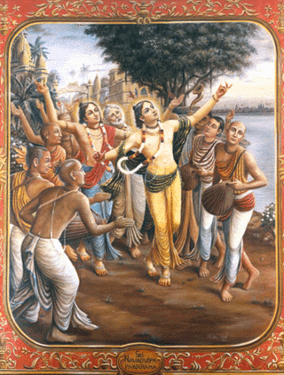
Lord Chaitanya Mahaprabhu leading a Sankirtan along with His associates
Then instead of listening to mundane music, one can begin listening to devotional songs that glorify Lord Krishna. However one must remain careful not to listen to unauthorized kirtans (devotional songs) since they are sung by impure “devotees” and are based on sentiments rather than devotion. If you are listening to any ISKCON kirtans or songs by people associated with ISKCON like ‘Rasa’ (my personal favorite) then you should be fine. Listening to devotional music purifies your consciousness. You can listen to it while travelling or at home or during any free times. Its as good as personally being at a Kirtan.
Then, instead of smelling your favorite flowers simply for your sense gratification, you can first offer them to Lord Krishna and then smell them. This is also a wonderful way of purifying your mind and senses and making progress in devotional life. Lord Krishna mentions in the 26th verse of the 9th chapter of Bhagavad Gita- patram pushpam phalam toyam yo mi bhaktya prayachete (When one offers to me with devotion a leaf, a flower, a fruit or a little water, I accept it.) Out of His mercy, Lord Krishna accepts any kind of offering made by His pure devotees with love and devotion. When one makes an offering without love and devotion, such an offering is not accepted. So one must keep in mind that in devotional life, it is not quantity that matters but it is quality. In other words, whatever be your capacity, serve accordingly, no matter if its too little service but do ensure that the little service is accompanied with a lot of love, devotion and selflessness. This way one receives tremendous love, mercy and compassion of the supreme lord.
In this and many other ways one can engage his senses in the service of the Lord but chanting the names and glories of the Lord is the best methods since it is the yuga dharma of kal yuga, to chant the name of Lord Hari in order to achieve freedom from the cycle of birth and death in this material word and to go back home, back to Godhead to enjoy transcendental pleasure in the association of the Supreme Lord Sri Krishna. Harer Nama Harer Nama Harer Namaivam Kevalam Kalau Nastey Eva Nastey Eva Nastey Eva Gatir Anyatha (Only and only by chanting the names of Lord Hari (Krishna) can one achieve liberation in the Kali Yuga. There is no other way. There is no other way. There is no other way.) Therefore one must engage in the incessant chanting of the Hare Krishna Mahamantra- Hare Krishna Hare Krishna Krishna Krishna Hare Hare/Hare Rama Hare Rama Rama Rama Hare Hare and experience transcendental pleasure while living in this material world which is full of unnecessary quarrel and fights. Chanting the Mahamantra, when one quits his body at the time of death, he without fail goes back home, back to Godhead. Thus by chanting the mahamantra, one leads a peaceful and joyous life and continues to enjoy even after death in the personal association of the Supreme Lord Sri Krishna in His abode Goloka Vrindavan. So keep chanting and be happy!
Hare Krishna!

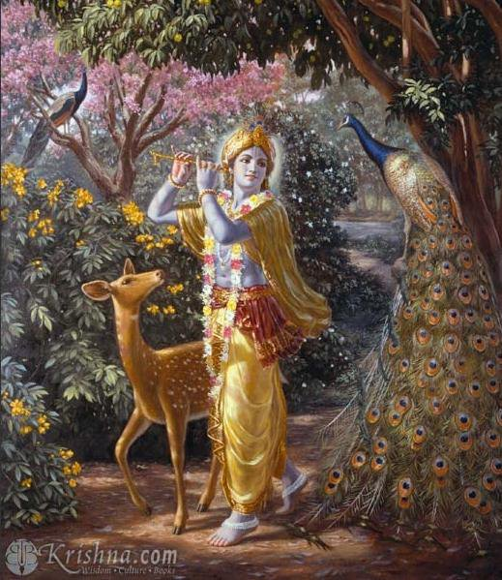
Lord Krishna in His abode Goloka Vrindavan

- The Original Home
When you ask someone “where is your home?” the person replies with his residential address. But if someone is asked “where is your original home?” he might not have an answer or may not be able to understand the question. This is owing to a conditioned soul’s identification of himself with his temporary material body and the bodily conception of life. It is due to this bodily conception of life that we consider this material world to be our home and permanent place of residence. This kind of illusion is caused due to our forgetfulness of Krishna and our relation with Him. Since we are parts and parcels of Lord Krishna, our original home is the supreme spiritual abode of Lord Krishna, known as Goloka Vrindavan (‘Go’ here refers to ‘cows’ and Vrindavan means the forest of mother Vrinda (Tulsi) devi.) Krishna eternally resides in His abode Goloka Vrindavan and we are the inhabitants of the Lord’s abode. But owing to our desires for sense gratification and disobedience in respect of the instructions of Lord Krishna, we have fallen into this material world which is full of misery and suffering, although due to illusion we take it as enjoyment.
In the Bhagavad Gita, chapter 15, text 6 Lord Krishna says- na tat bhayasata suryo na shashanka na pavakha yad gatva na nirvartante tat dhama paramam mama. (There is no sun, moon, fire or electricity there, but the one who comes to my supreme abode once, never falls down into the material world again.) There is no need for the sun, moon, fire or electricity in the abode of the supreme lord, since He is personally present there. In the 11th chapter of Bhagavad Gita when the Lord showed His universal form to Arjun, Arjun told the Lord that he could see that the sun and moon were the two eyes of the universal form of the Lord. Thus we can understand that Lord Krishna is superior even to the sun and moon gods. This is further substantiated in the 4th chapter of the Bhagavad Gita where the Lord informs Arjun that initially He had instructed the knowledge of the Bhagavad Gita to the sun god Vivasvan who passed it on to Manu the father of mankind, who later passed it to Iksavaku thus forming a disciplic succession which later broke and the teachings of the Lord were forgotten. Thus to revive the disciplic succession, Lord Krishna instructed the Gita to Arjun.
In the Srimad-Bhagavatam we find descriptions of Lord Krishna’s eternal home, such as this one:
“Goloka, also called Vrindavana, is always full of cows. There are many waterfalls, which are always pouring water, and the sound is so sweet that it covers the sound of the crickets. And because water flows all over, the forest always looks very green and beautiful.
“The inhabitants of Vrindavana are never disturbed by the scorching heat of the sun or high summer temperatures. The lakes of Vrindavana are surrounded by green grasses, and various kinds of lotus flowers bloom there. The air blowing in Vrindavana carries the aromatic pollen of those lotus flowers. When the particles of water from the waves of the Yamuna River, the lakes, and the waterfalls touch the bodies of the inhabitants of Vrindavana, they automatically feel a cooling effect.
“Vrindavana is such a nice place. Flowers are always blooming, and there are even various kinds of decorated deer. Birds are chirping, peacocks are crowing and dancing, and bees are humming. The cuckoos there sing nicely in five kinds of tunes.
“Krishna, the reservoir of pleasure, blowing His flute, accompanied by His elder brother Balarama and the other cowherd boys and the cows, enters the beautiful forest of Vrindavana to enjoy the atmosphere. They walk into the midst of newly grown leaves of trees whose flowers resembled peacock feathers. They are garlanded by those flowers and decorated with saffron chalk. Sometimes they are dancing and singing and sometimes wrestling with one another. While Krishna dances, some of the cowherd boys sing and others play on flutes; some bugle on buffalo horns or clap their hands, praising Krishna, ‘Dear brother, You are dancing very nicely.’ ”
“I worship Govinda, the primeval Lord, the first progenitor, who is tending cows yielding all desires in abodes built with spiritual gems and surrounded by millions of purpose trees. He is always served with great reverence and affection by hundreds and thousands of goddesses of fortune.” –Sri Brahma-samhita 5.29

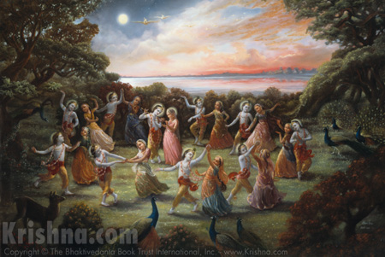
Lord Krishna enjoying the Rasa lila in His eternal abode Goloka Vrindavan.
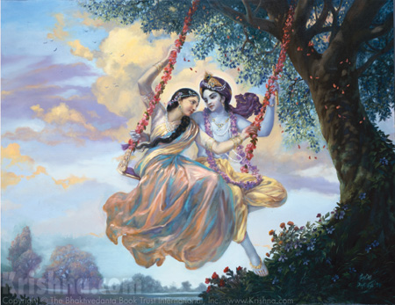Lord Krishna and Srimati Radharani enjoying the madhuryarasa in Goloka Vrindavan.
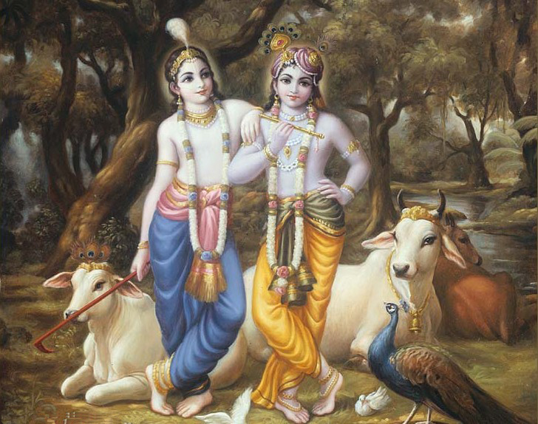
Lord Sri Krishna and Baladeva in Goloka Vrindavan.
So how can we who are presently inhabiting this material world, ever associate with the Supreme Lord Krishna in His wonderful abode? Although this is Kali Yuga the age of darkness, unnecessary quarrels and fights, still there is one major merit of this age and that is the simple process of deliverance from the ocean of material miseries. This simple process is known as Harinama Sankirtan or chanting the names and glories of the Supreme Lord Sri Krishna who is also known as Hari- the deliverer of the fallen souls. For establishing the Harinama Sankirtan Movement in this material world, Lord Krishna came in the form of Lord Chaitanya Mahaprabhu in the 15th century, in West Bengal, India. He popularized the chanting of the Hare Krishna Mahamantra the chanting of which cleanses the mind of all material conditioning. The one who chants it at the time of his death is sure to go back home, back to godhead since whatever state one thinks of at the time of his death, that state he achieves in his next birth without fail. Thus it is necessary to chant the Holy names of Lord Krishna incessantly so that at the time of death (which can occur anytime) one can easily remember Krishna and go back to the original home, back to Godhead!
Hare Krishna!

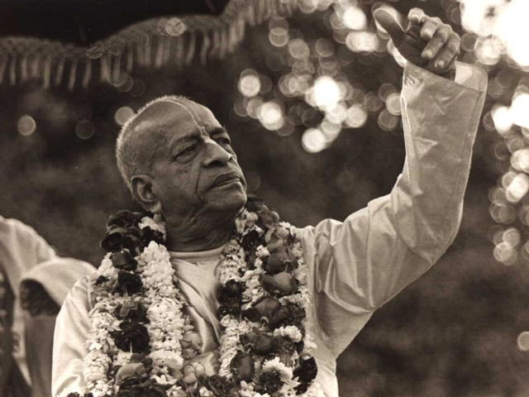
Srila Prabhupada the Founder Acharya of ISKCON emphasized on simple living and high thinking since they are the foundations stones of spiritual life.
5.Simple Living and High Thinking.
As conditioned souls, we are always hankering for objects of sense gratification in order to live a luxurious and comfortable life. In order to fulfill this desire for sense gratification we are struggling in this material world day in and day out. In the course of this struggle we are exploiting the natural resources of the world like fossil fuels, minerals, forests, animal life etc. The reason for this unending exploitation of natural resources is man’s greed, lust and uncontrolled senses. The results of such unrestricted exploitation of the resources of the material nature are issues like global warming, increased prices of essential commodities like food grains, economic issues resulting in rampant unemployment and a variety of other issues. These social, economic and political problems are caused due to our forgetfulness of Krishna as the Supreme Personality of Godhead. We tend to forget that He is the supreme proprietor and the one who provides all living entities with all that they need to sustain themselves in this material world. We have a tendency of trying to lord over material nature but in our every attempt to do so we are reminded that we are not supreme as the atheists think they are. What we need to understand is that we are not the proprietors of anything, not even of our own bodies! Ishavasya Idam Sarvam- Everything belongs to God. There is nothing like “private property” in reality. Our position is just like that of a cashier in a bank. Millions of dollars pass through his hands everyday but can he claim even a single penny from them? No! Thus, as long as we are in the material world, we should strive to engage all the available resources in the service of Lord Krishna who is the supreme creator and proprietor. This is the process of Krishna Consciousness, engaging all our senses, resources and possessions in the service of Lord Krishna the Supreme Personality of Godhead. One must understand that whatever he possesses is due to the mercy of Lord Krishna and the same must be employed in His service. This makes human life successful, peaceful and happy. When we realize that all our possessions are actually the property of Lord Krishna and we begin to engage them in the service of Lord Krishna then there will be no conflict in the world. No one shall encroach upon the property of others since everyone shall know that Krishna is the proprietor of everything. This will put an end to unnecessary fights, quarrels and conflicts which today plague every nook and corner of this material world.
One may ask that how is it possible for an ordinary worldly man to engage his possessions in the service of Lord Krishna? It is not very difficult. Only a change in the point of view is required. Instead of viewing everything as your personal possession, view it as Krishna’s property which has been given to you not for your enjoyment but so that you may engage it in the service of Krishna. For example take your cell phone. One may use it in so many ways to serve Krishna. Whenever you receive a call, answer it by saying “Hare Krishna!” instead of the usual “Hello”. Keep wallpapers of Krishna in your cell phone. Listen to devotional songs glorifying Krishna in mp3. Watch Krishna Conscious videos and also share them with your friends, relatives and colleagues. This way also you can spread the message of Krishna! Listen to lectures on Bhagavad Gita and Srimad Bhagavatam on your cell phone. In these and so many other ways one can engage his cell phone in serving Krishna. Similarly find out ways of serving Krishna with the help of your other possessions. This will make your possessions spiritual!
You can even engage yourself in serving Krishna by working in a company or carrying out your business! How is it possible? Wherever you work, work in a state of mind that you are not serving your boss or that you are working for yourself or your family. Work thinking that you are working for Krishna. Whatever income one earns the same must be employed in Krishna’s service. Donate money to organizations working to spread the message of Lord Krishna all over the world. Utilize your money to purchase food grains, vegetables, fruits and milk products to prepare food for Lord Krishna and then eat the prasadam along with your family. Use your income for purchasing flowers, incense sticks, fruits, clothes etc for Lord Krishna. In this manner even an ordinary grahasta medhi (house holder) can engage himself and his family in serving Lord Krishna. Make Krishna the centre of everything at home instead of the television. This will make your family environment peaceful and joyous.
The method of leading a simple life is very easy and practical in modern times. You only need to chant the mahamantra Hare Krishna Hare Krishna Krishna Krishna Hare Hare/ Hare Rama Hare Rama Rama Rama Hare Hare. Chant this mahamantra as much as you can. It will clear all the impurities of your mind and sow the seed of devotion in your heart. Then follow the four regulative principles of no meat eating, no intoxication, no illicit sex and no gambling. By incessantly chanting the Hare Krishna Maha mantra, following the four regulative principles and regularly discharging loving devotional service to Lord Krishna your life becomes spiritual, peaceful and successful. Since the process of Krishna Consciousness is so simple, anyone from any background can take it up and improve his/her life. By leading a life of simplicity and high thinking one transcends the modes of material nature and becomes a fit candidate to go back home, back to Godhead.
Hare Krishna!

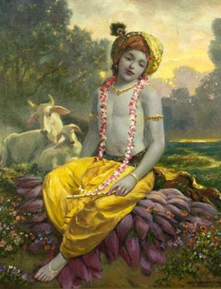

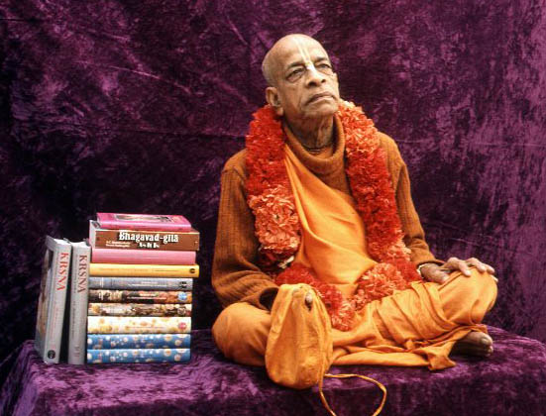
Dedicated to His Divine Grace A.C. Bhaktivedanta Swami Prabhupada, Founder Acharya of the International Society for Krishna Consciousness.
Written, Edited, Published and Distributed by,
Rasabihari dasa (Vinay Chakraborty)

Do send us your views, comments and queries at vinay.chakraborty@yahoo.com
For more information visit- www.soldiersofgodhead.yolasite.com

Hare Krishna!

